**IMAGE CLASSIFICATION**

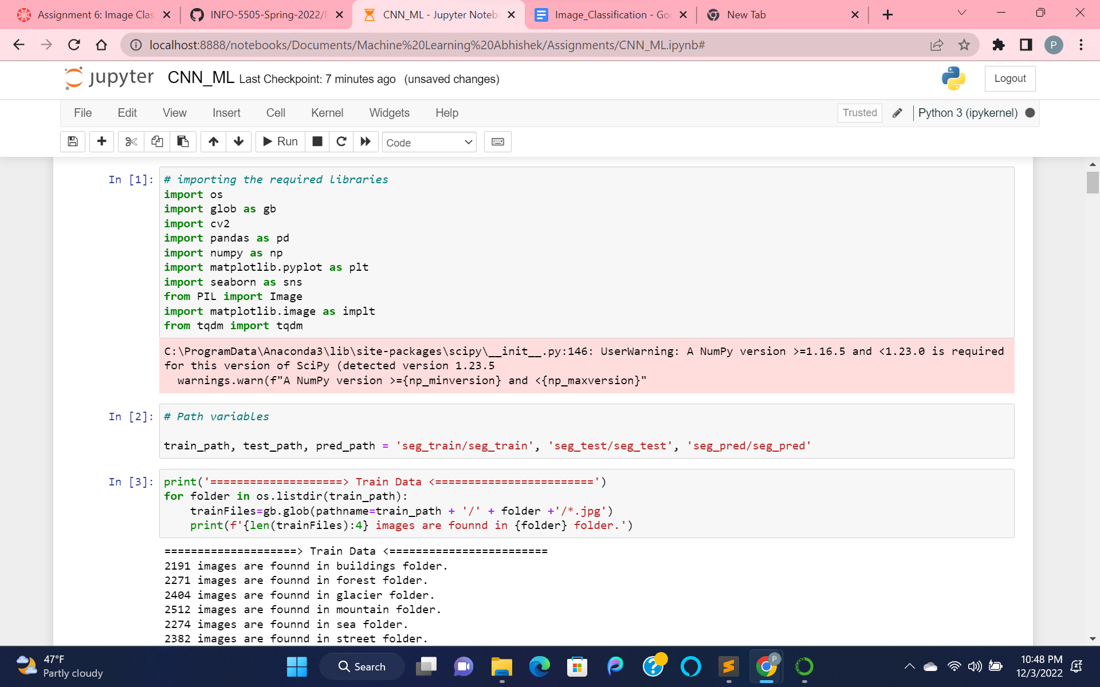

Importing the required libraries and mentioning the path for the train, test, prediction data.

Then, processing the images dataset, by analyzing them for training data by checking the number of image records and their shape.

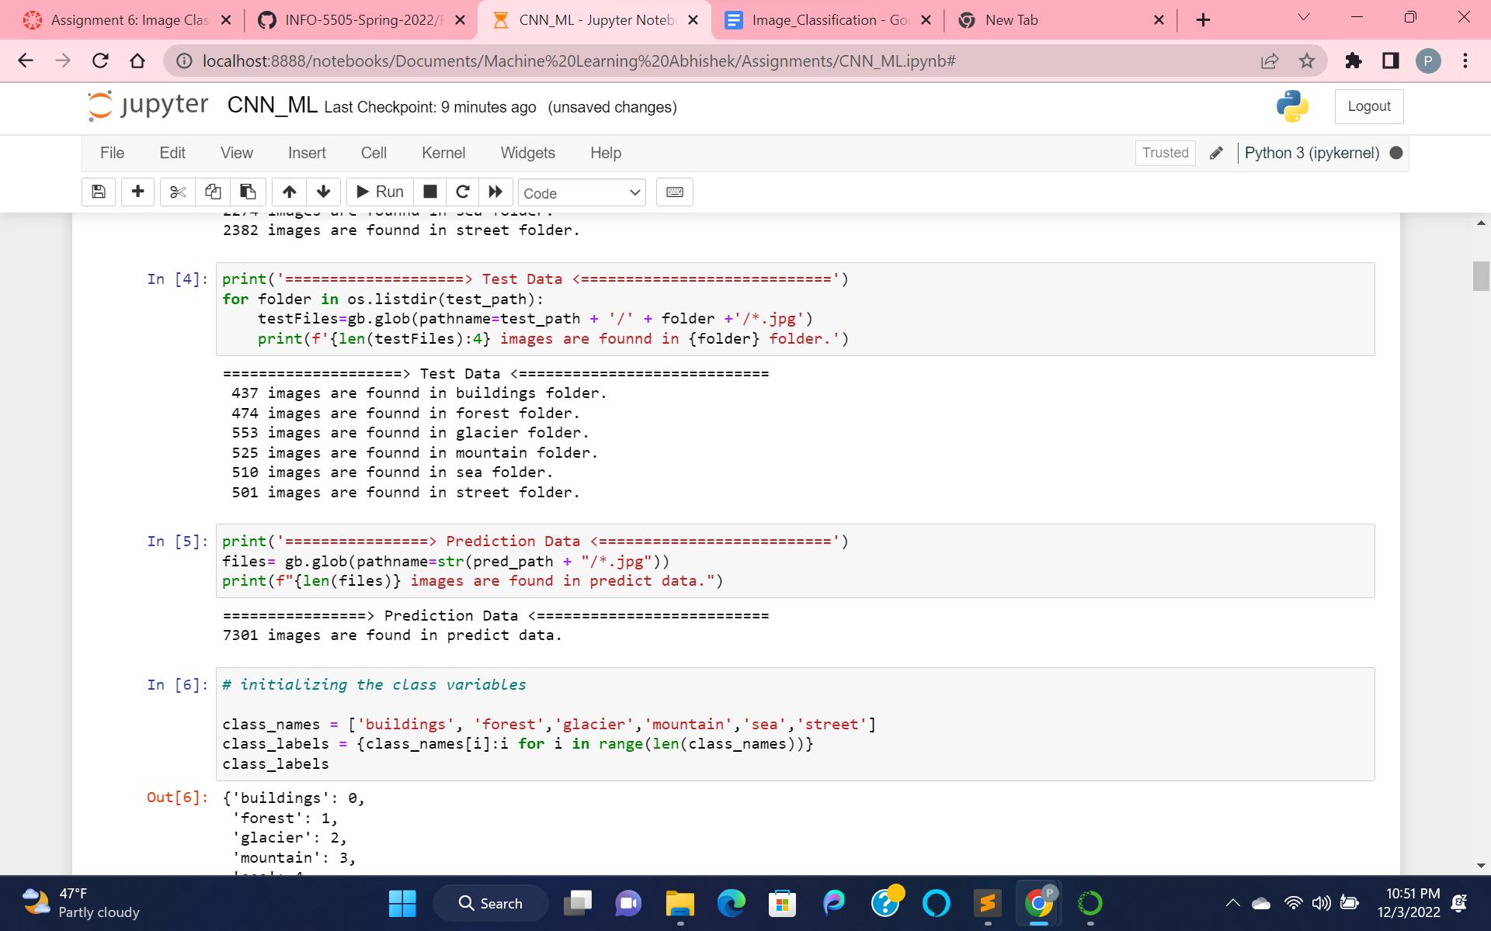

Analyzing the data for test and prediction data.

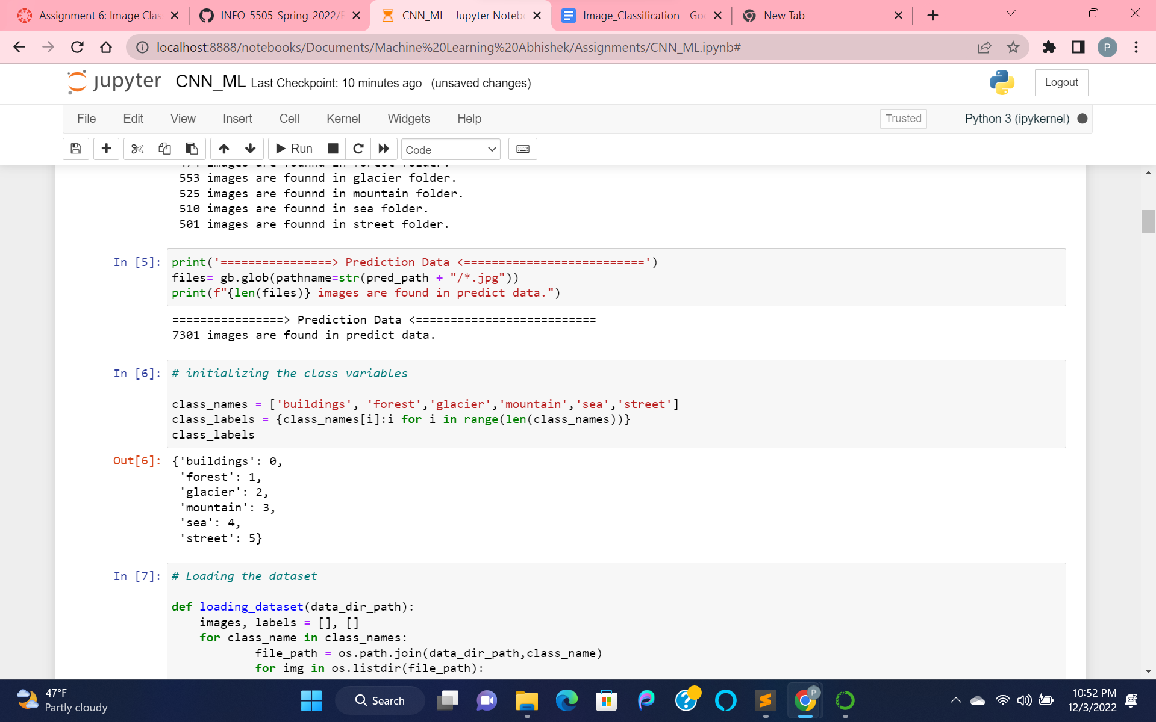

Displaying the labels for our data.

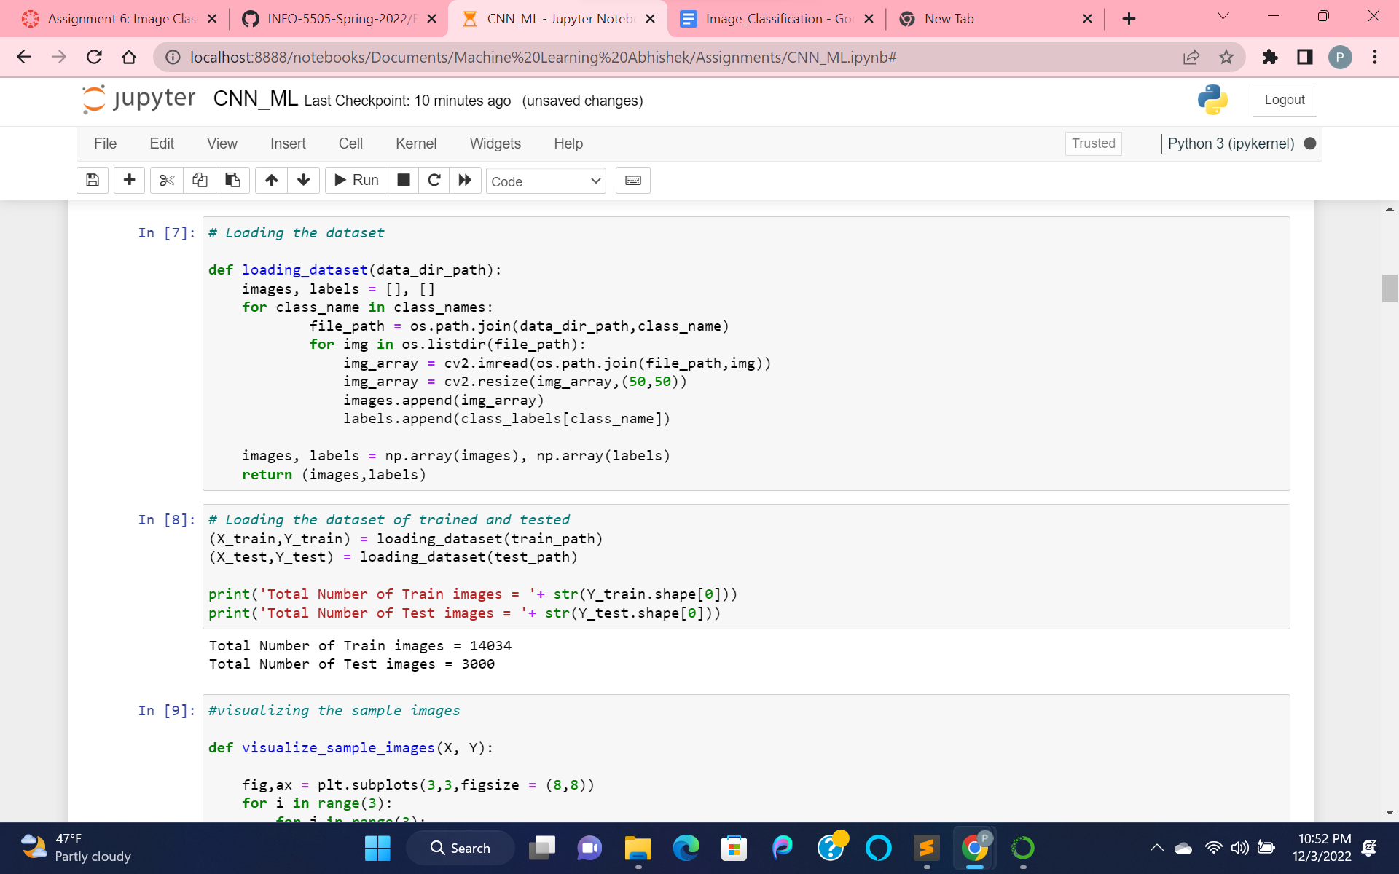

Loading the training and testing dataset into X, Y.

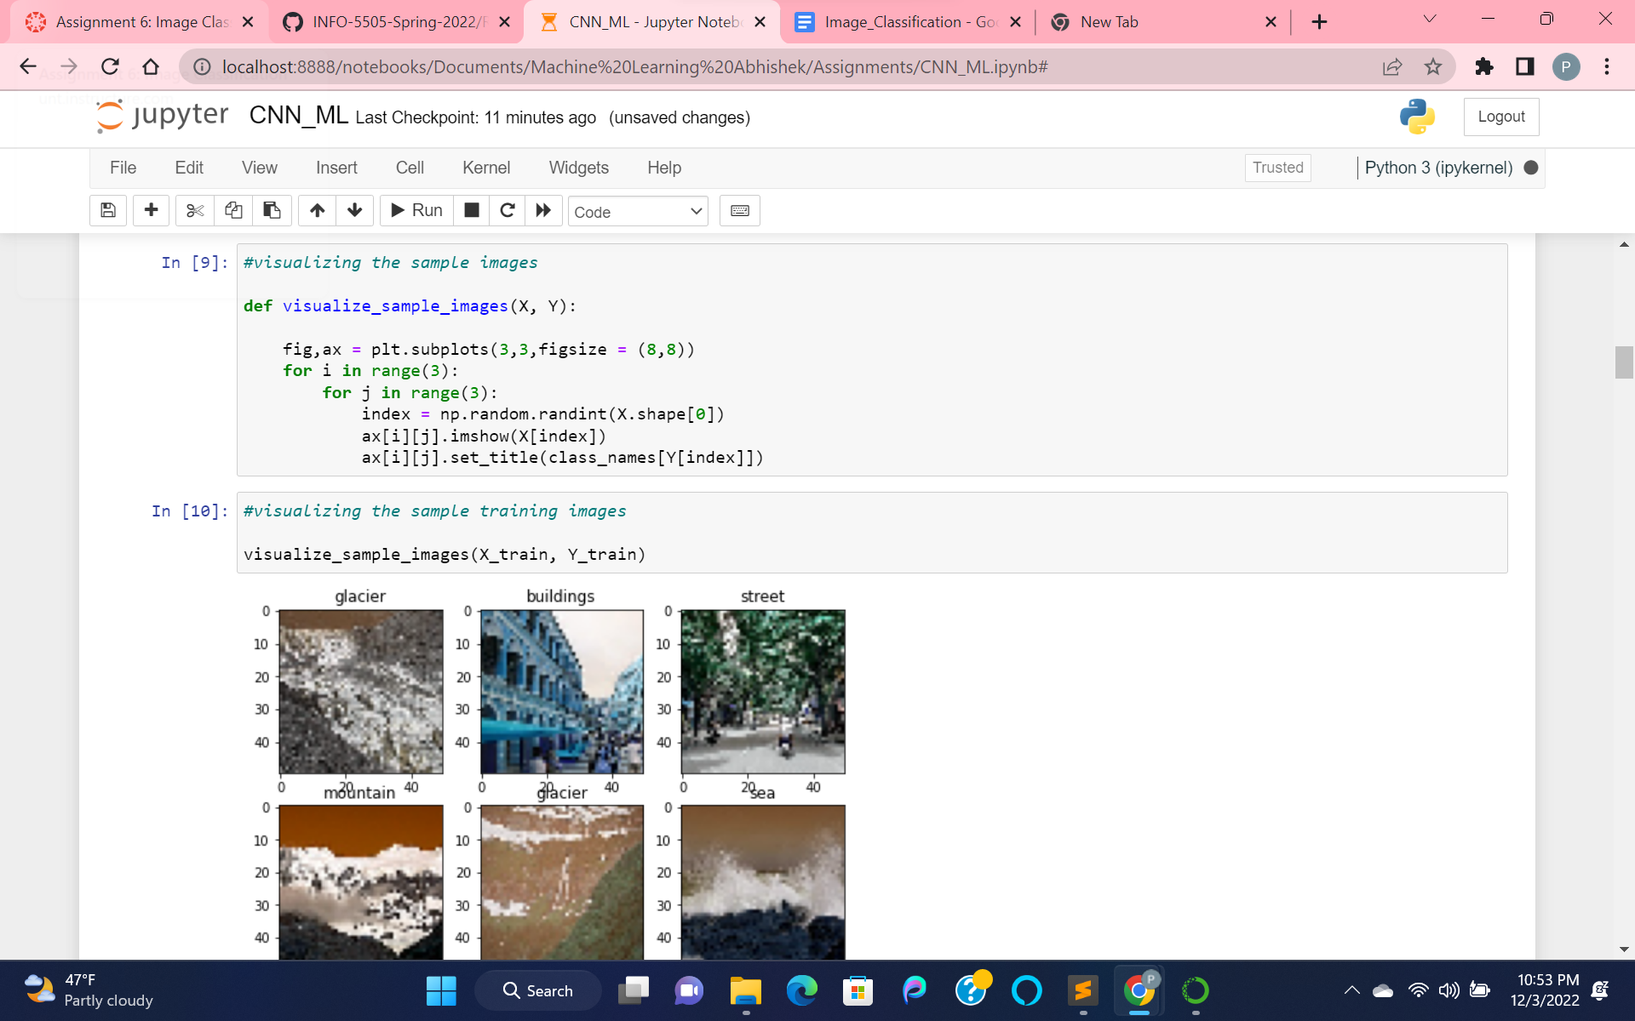

Displaying the samples of train data

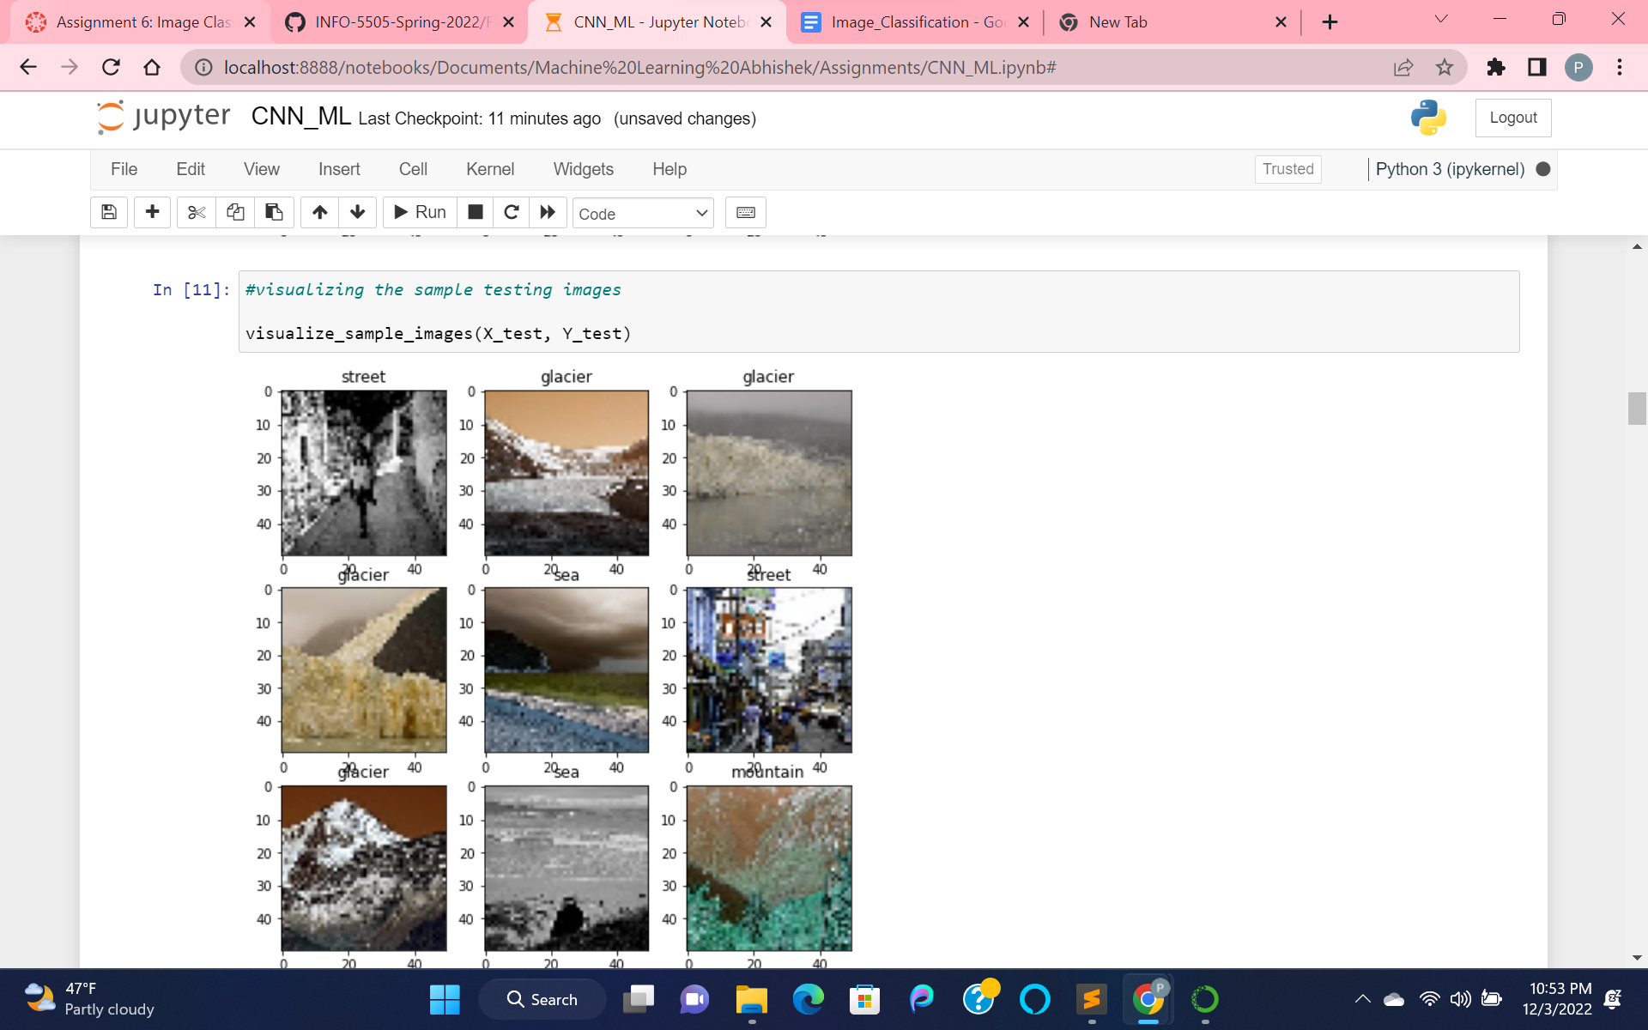

Visualizing the sample for tested data.

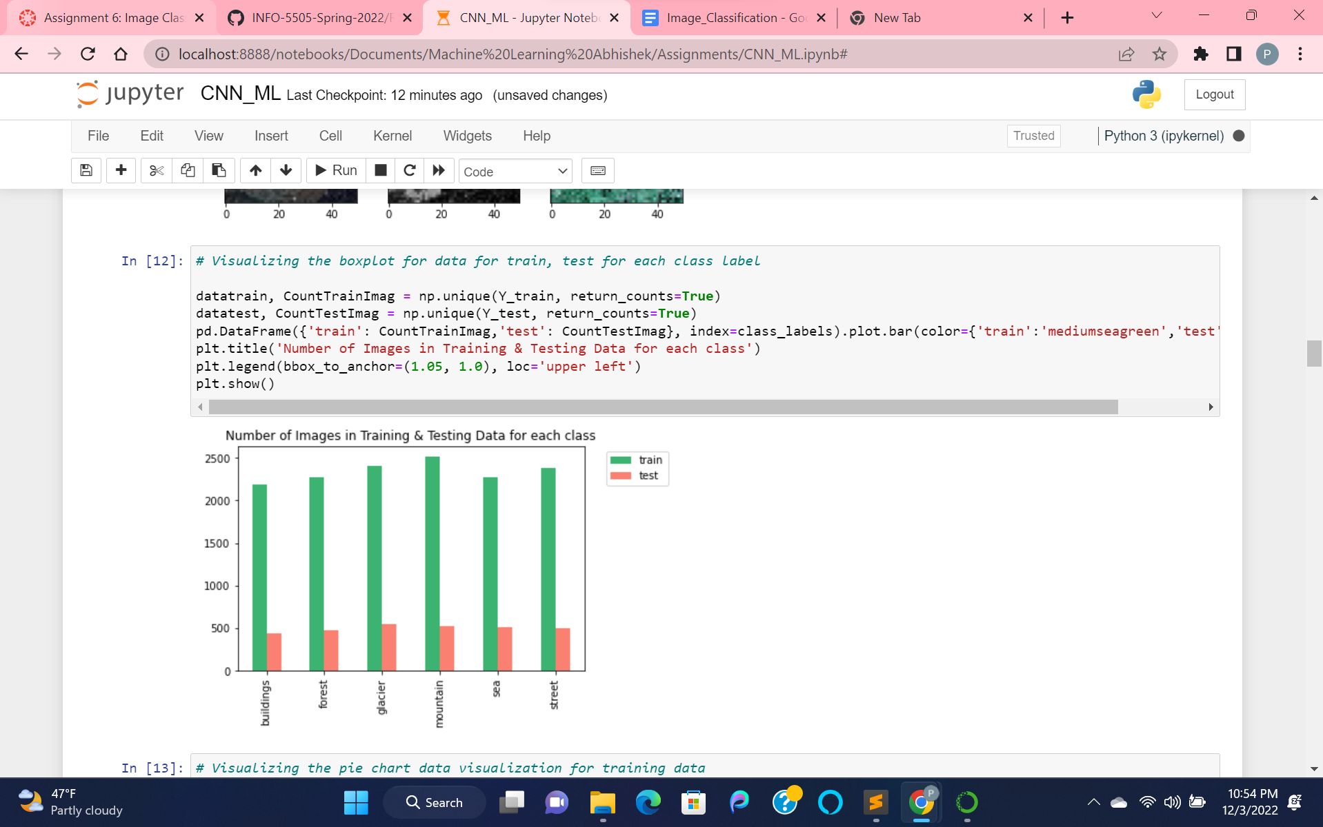

Boxplot for labels of our data for both train and test data.

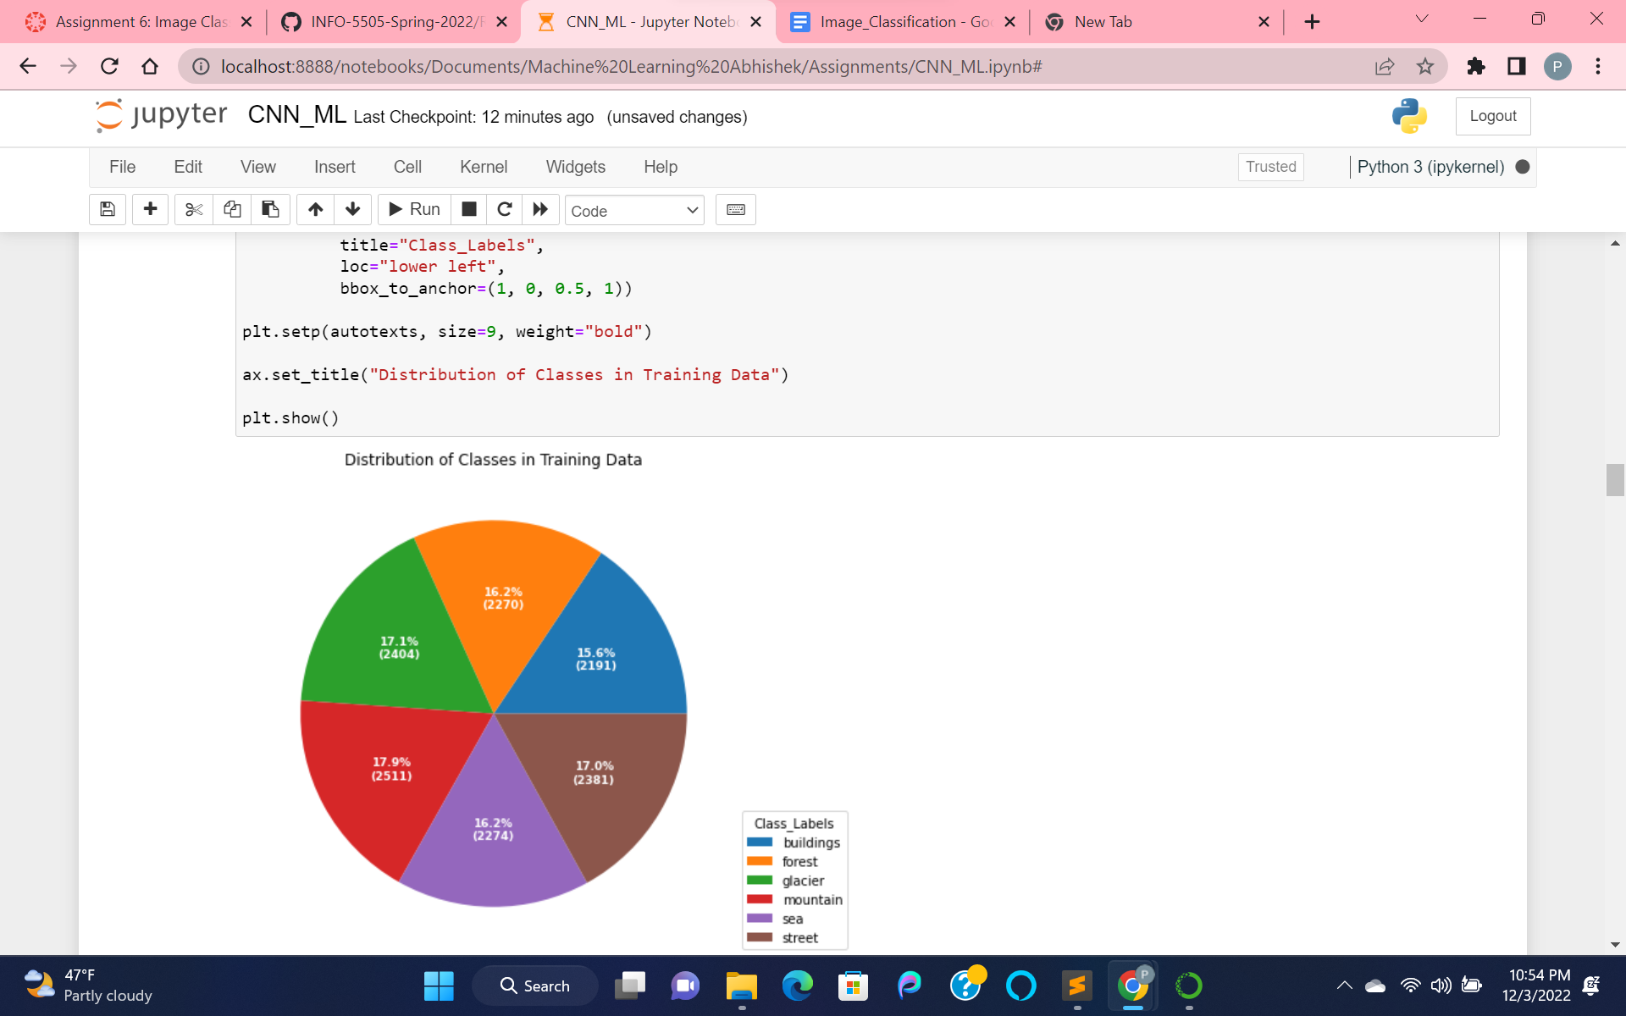

PieChart for labels of our data for train data

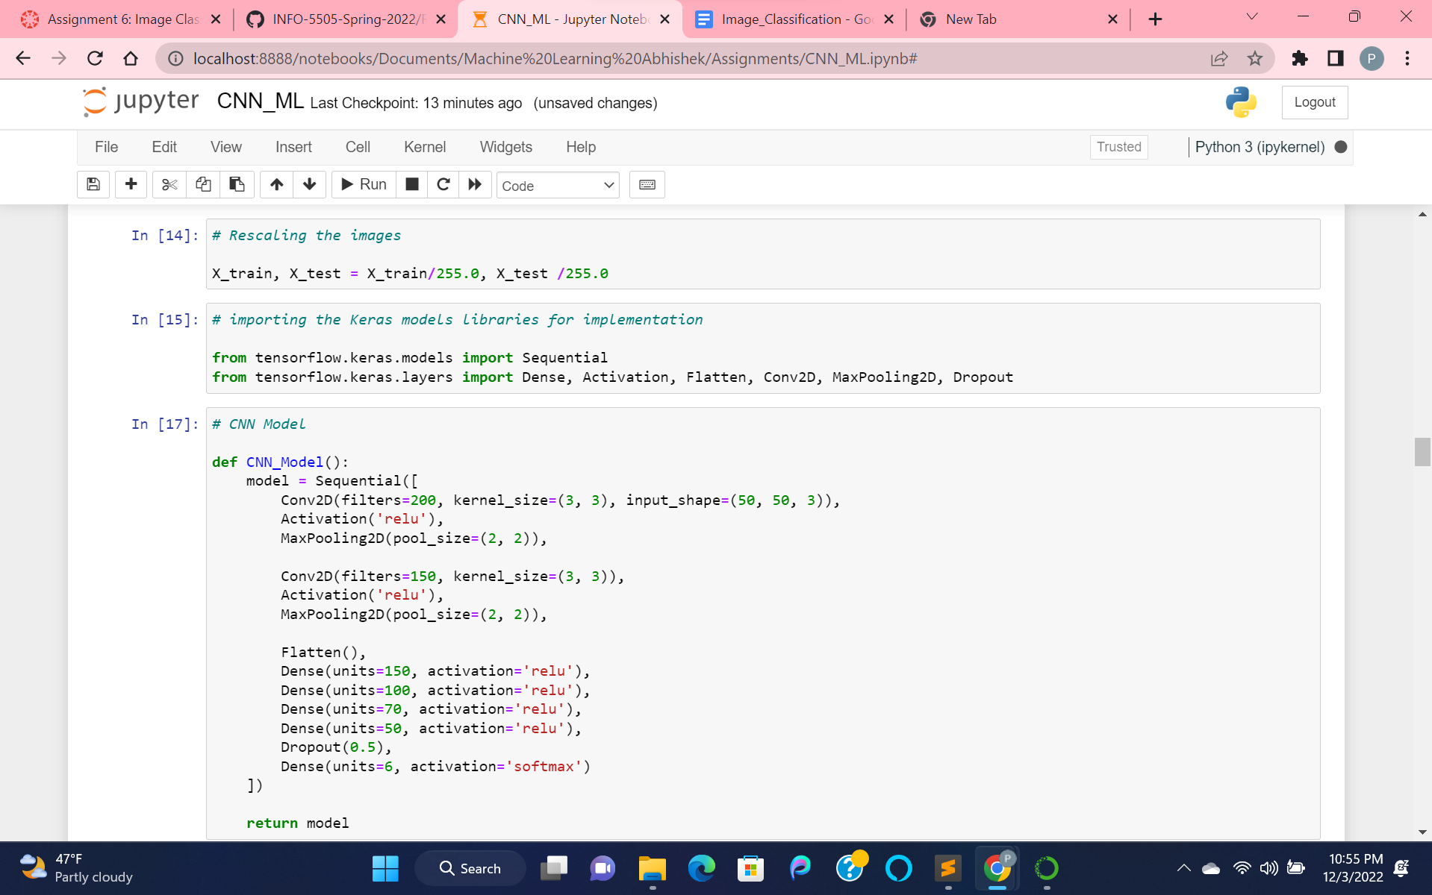

Rescaling and building our CNN model

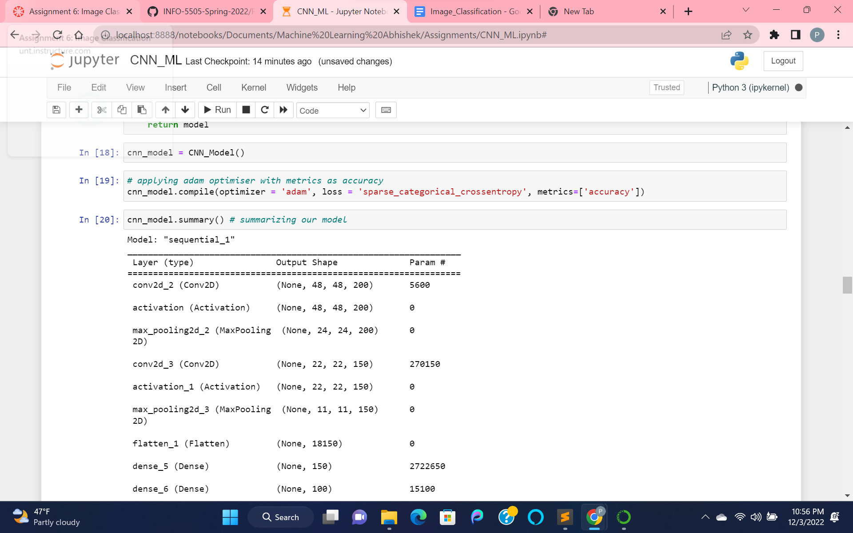

Compiling our model based on adam optimizer and metrics as accuracy.

And then summarizing our model.

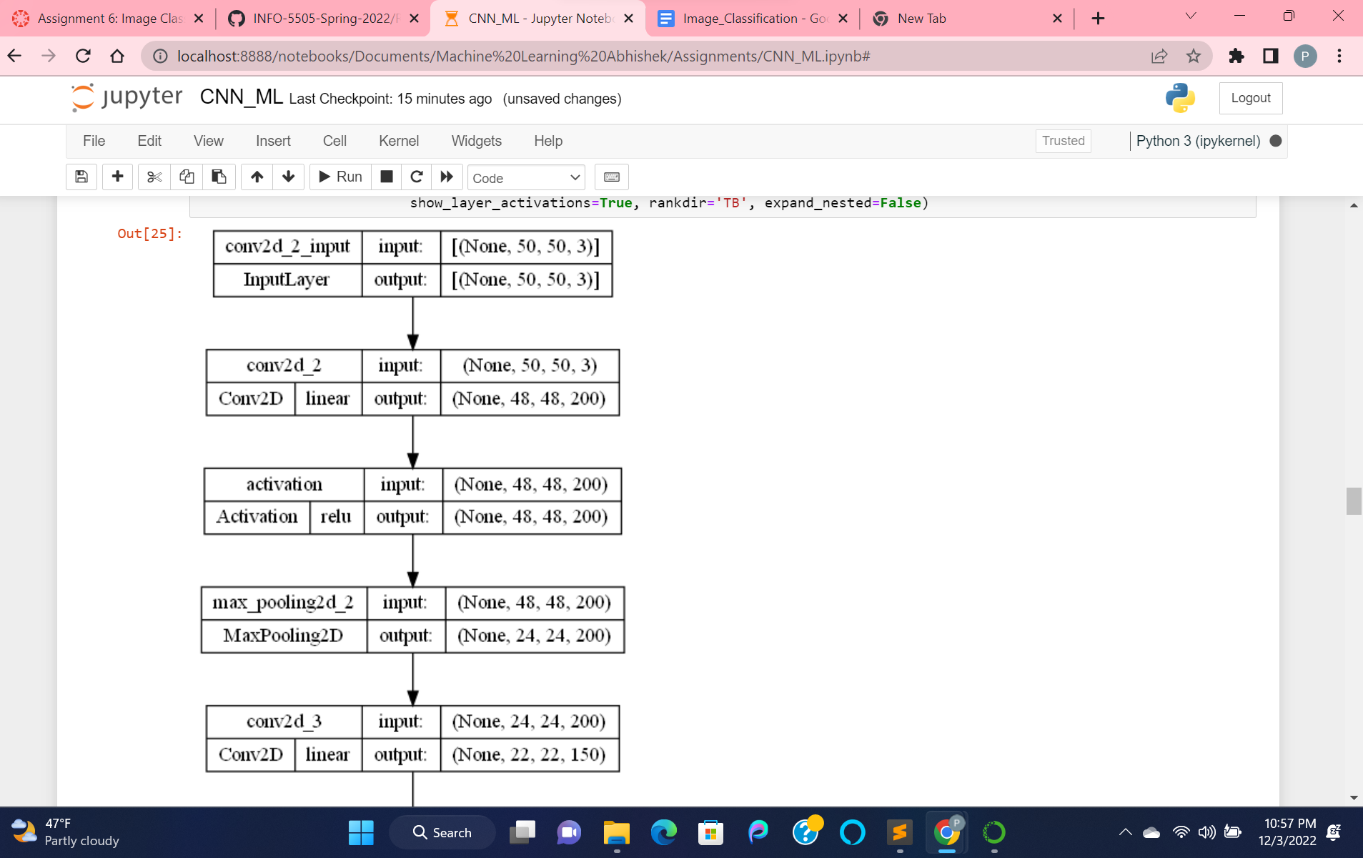

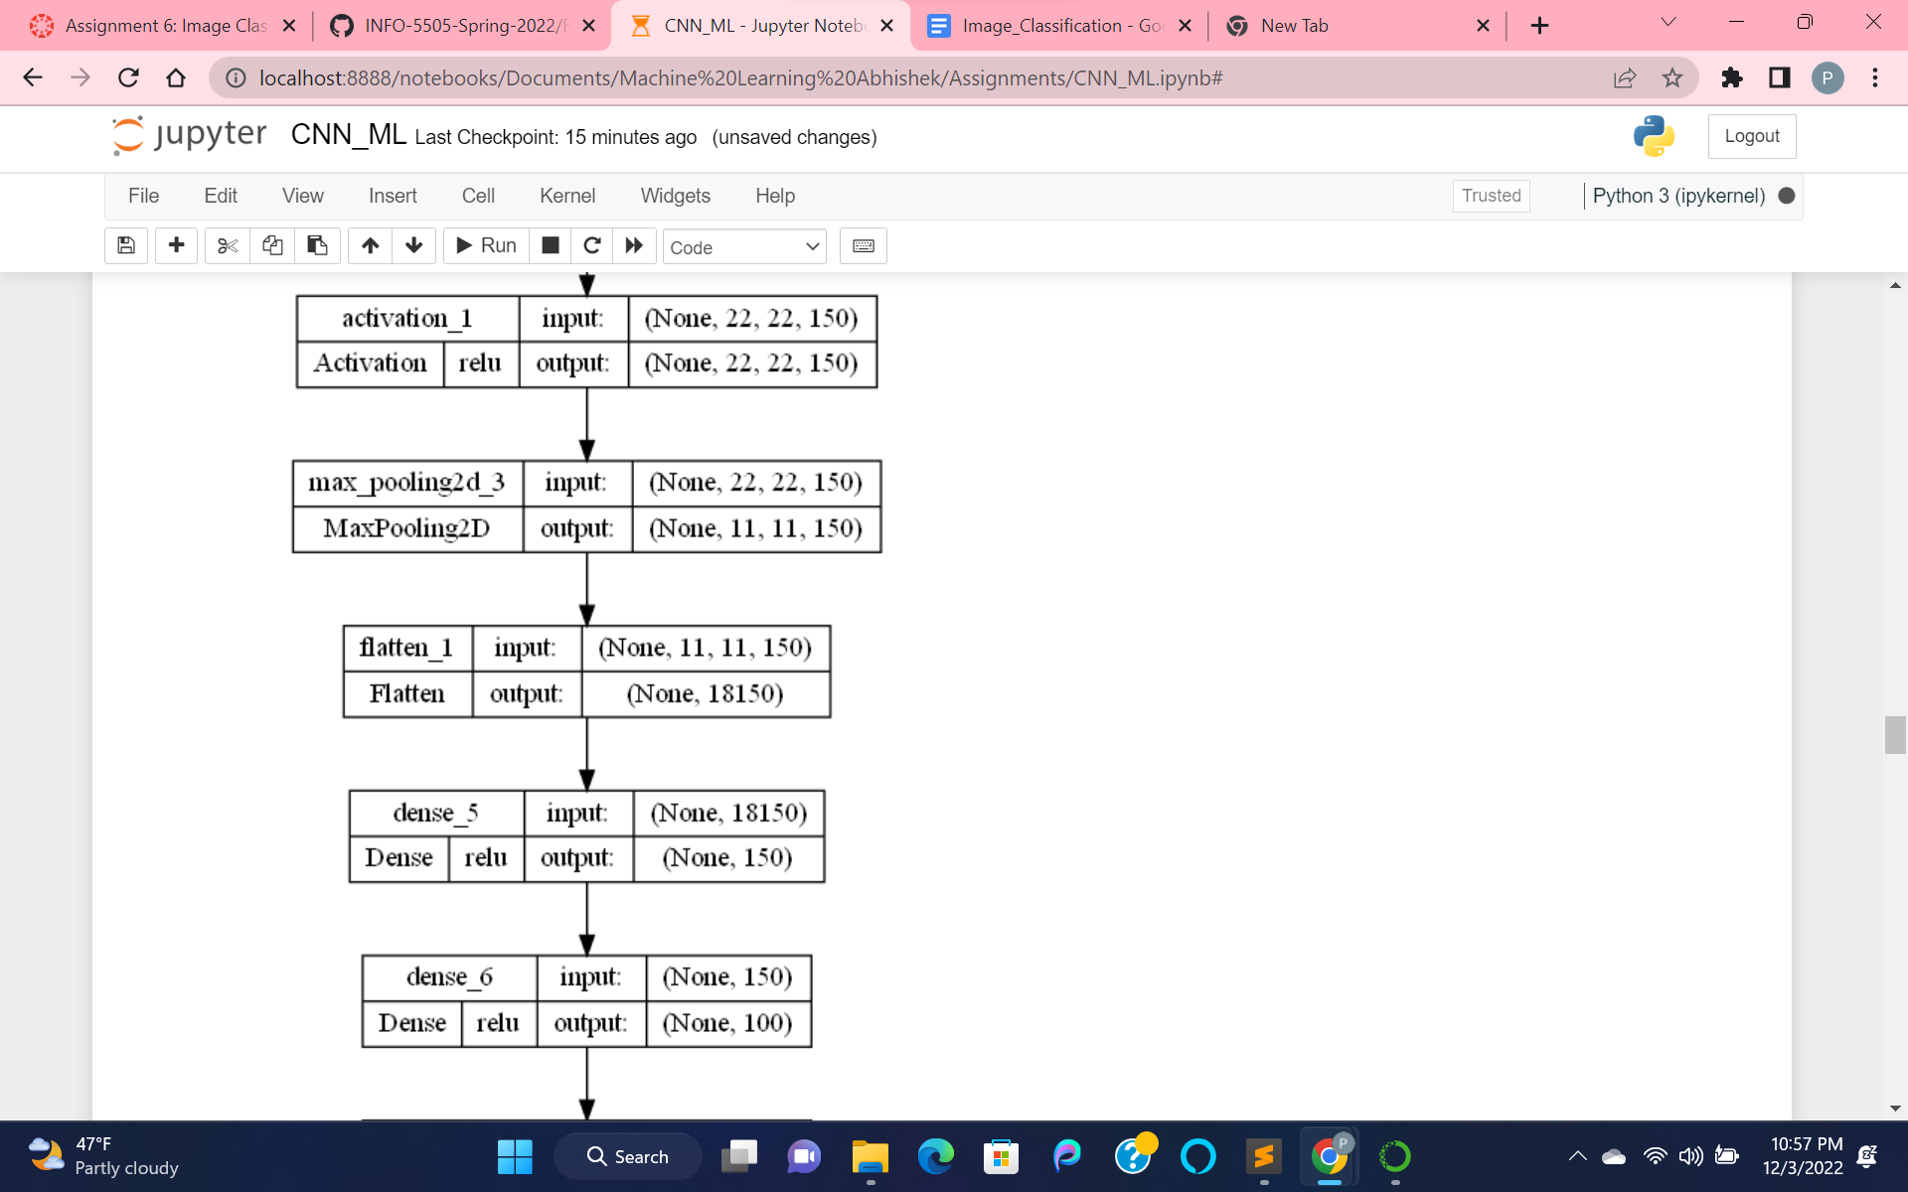

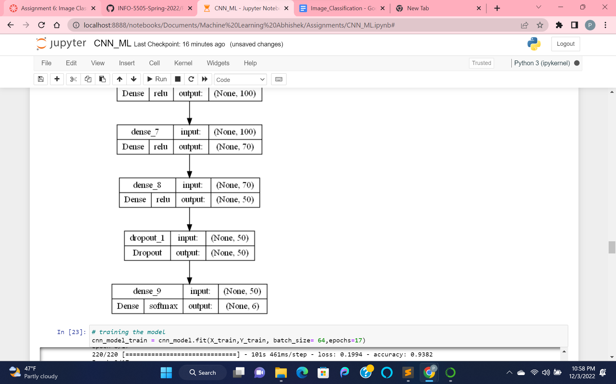

Visualizing the layers of our model

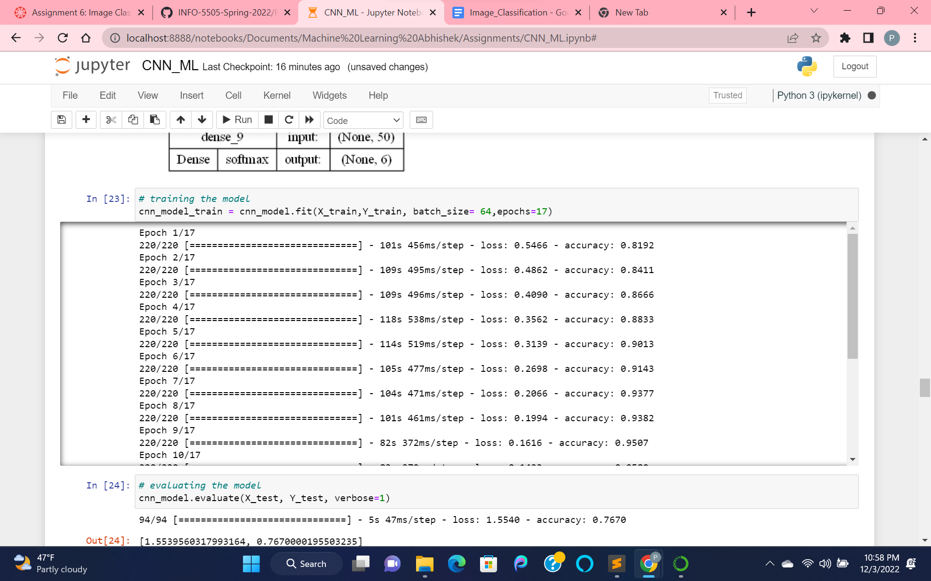

Training model with epoch =17 and evaluating our model, with accuracy 76.7% [Epoch means once all images are processed one time individually for forward and backward to the network, then that is one epoch or training the neural network with all the training data for one cycle].

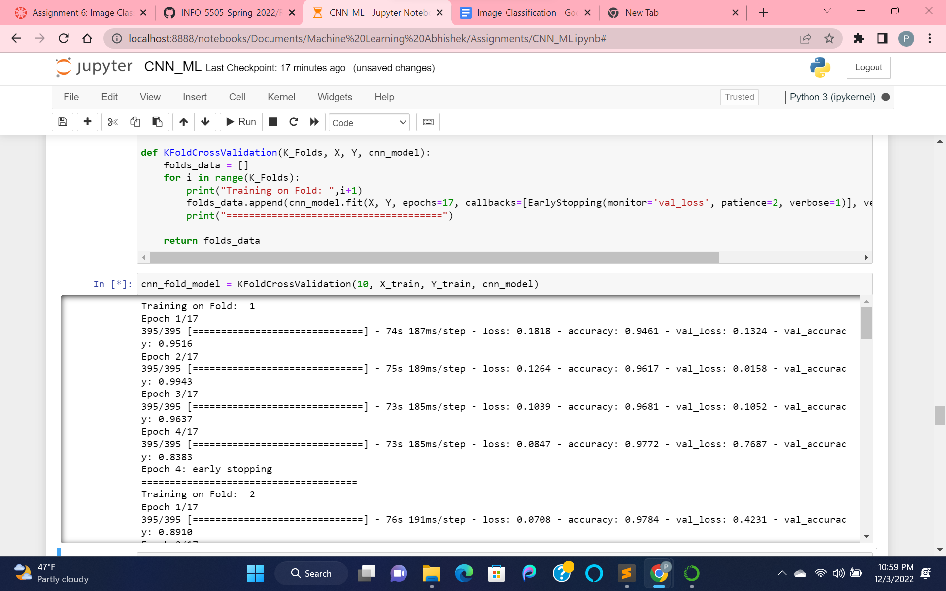

Performing the KFold Validation on our model, with value as 10.

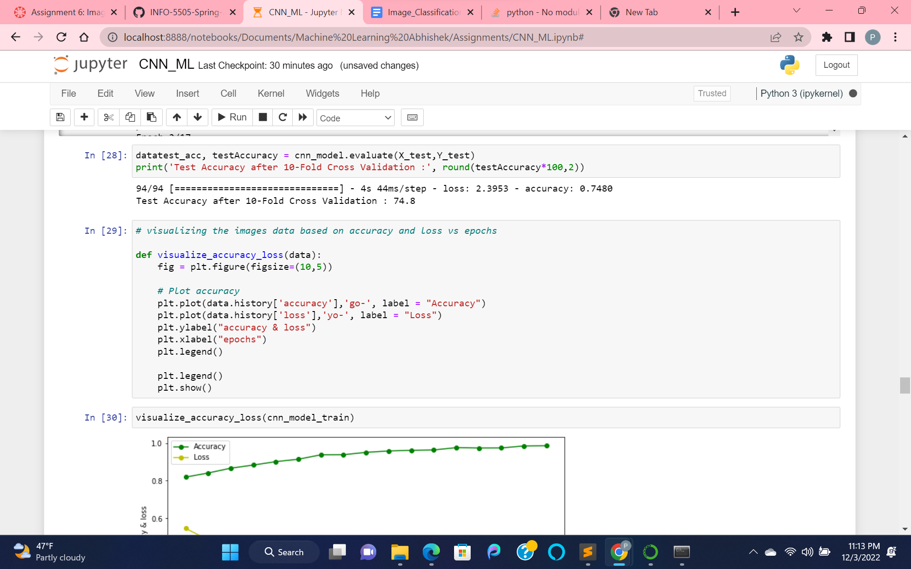

Test accuracy for cnn model by evaluating it. We got 74.8%

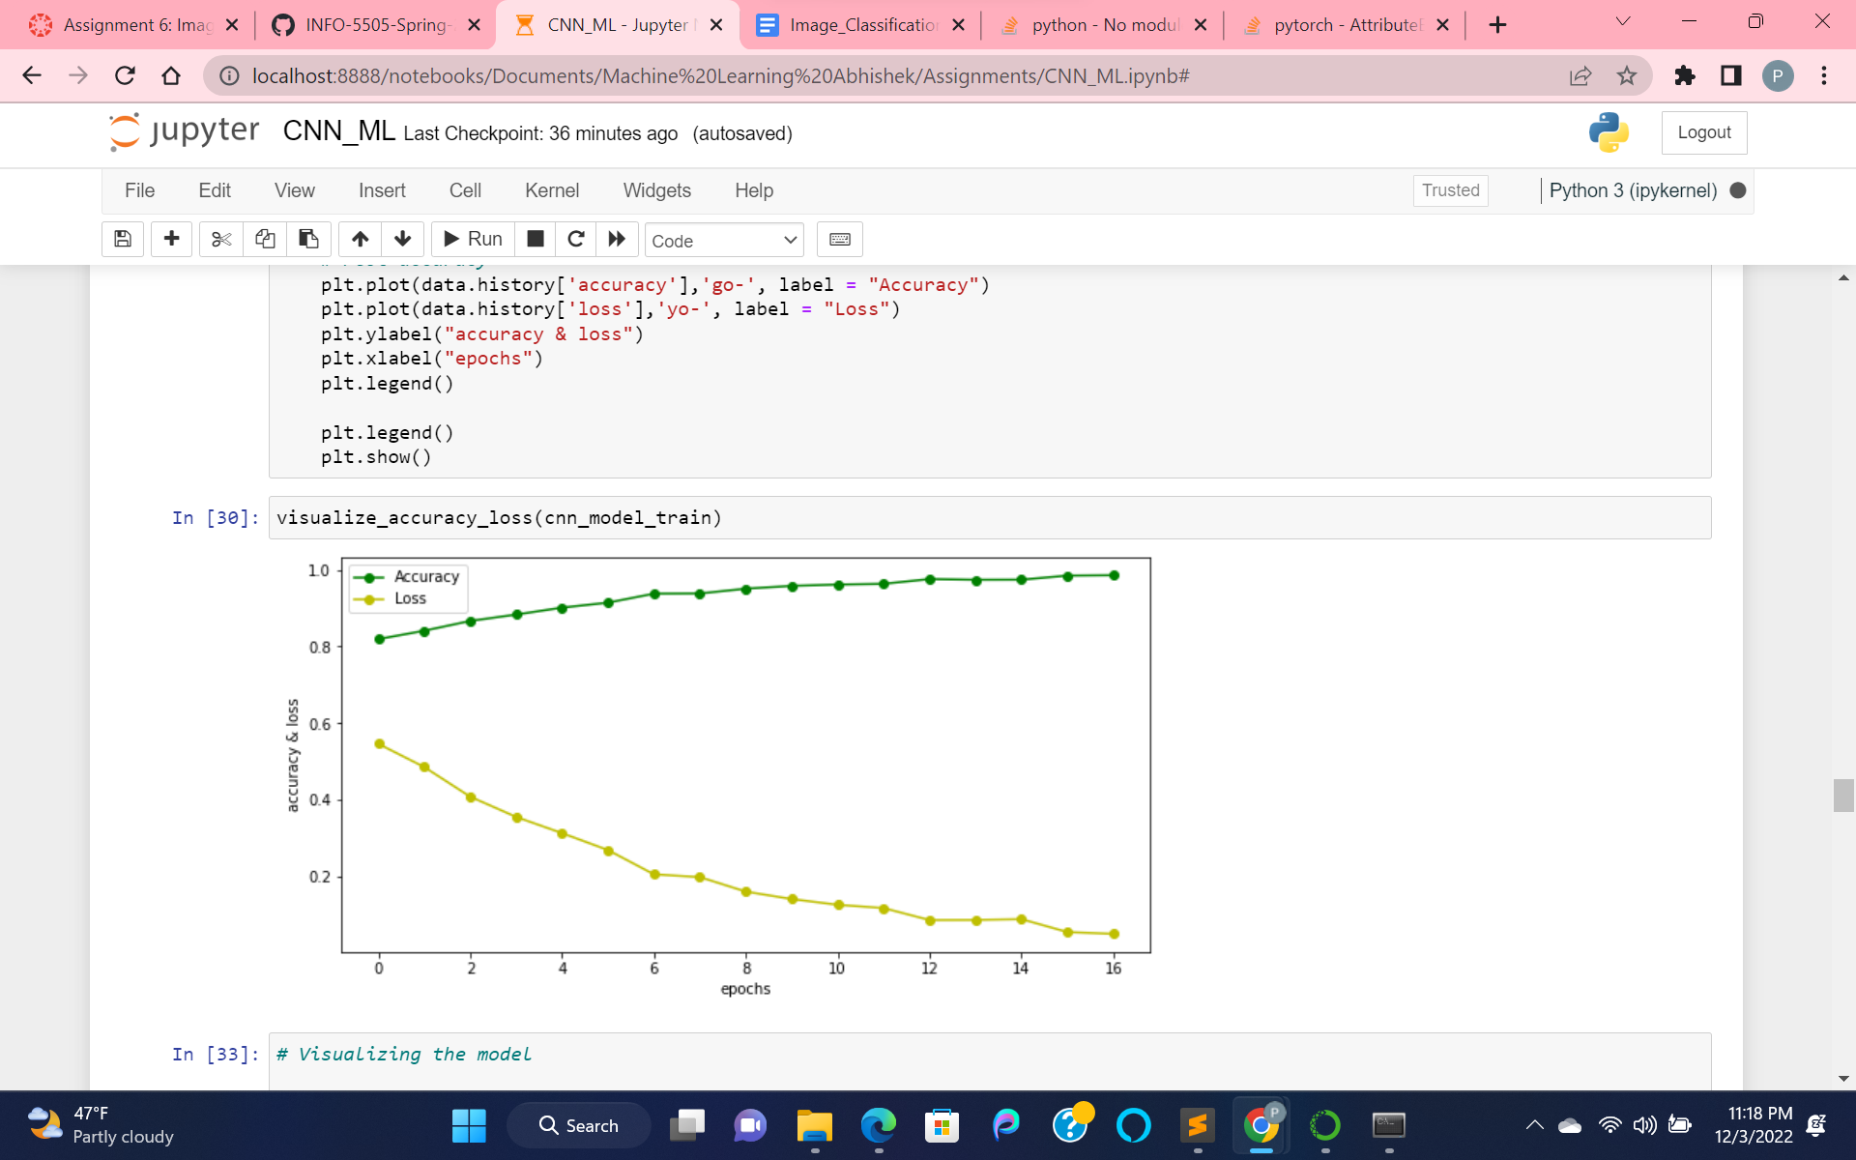

Visualizing the accuracy_loss processing data vs no_of_epochs that we took.

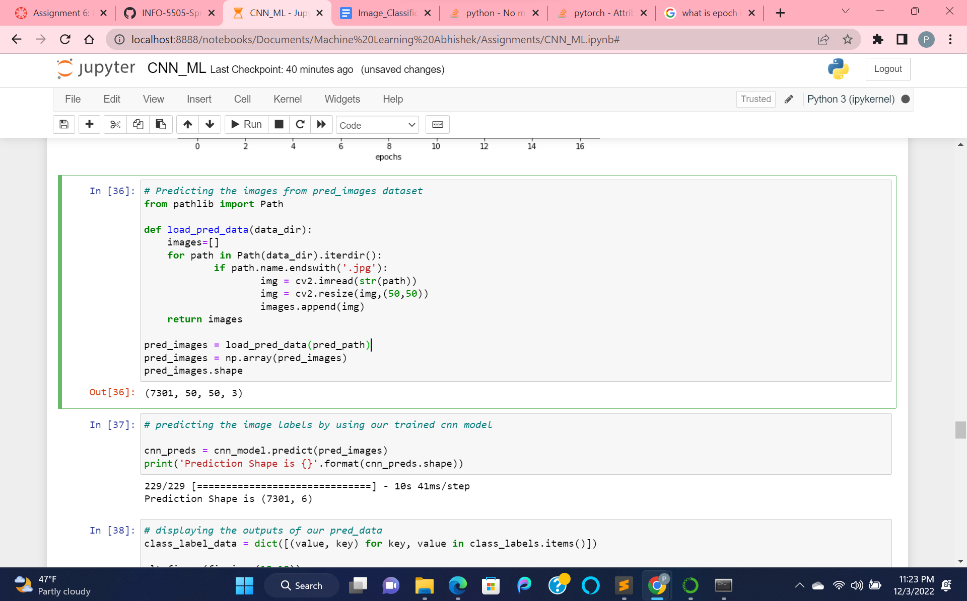

Predicting the images for our seg_pred dataset with only image data and no label.

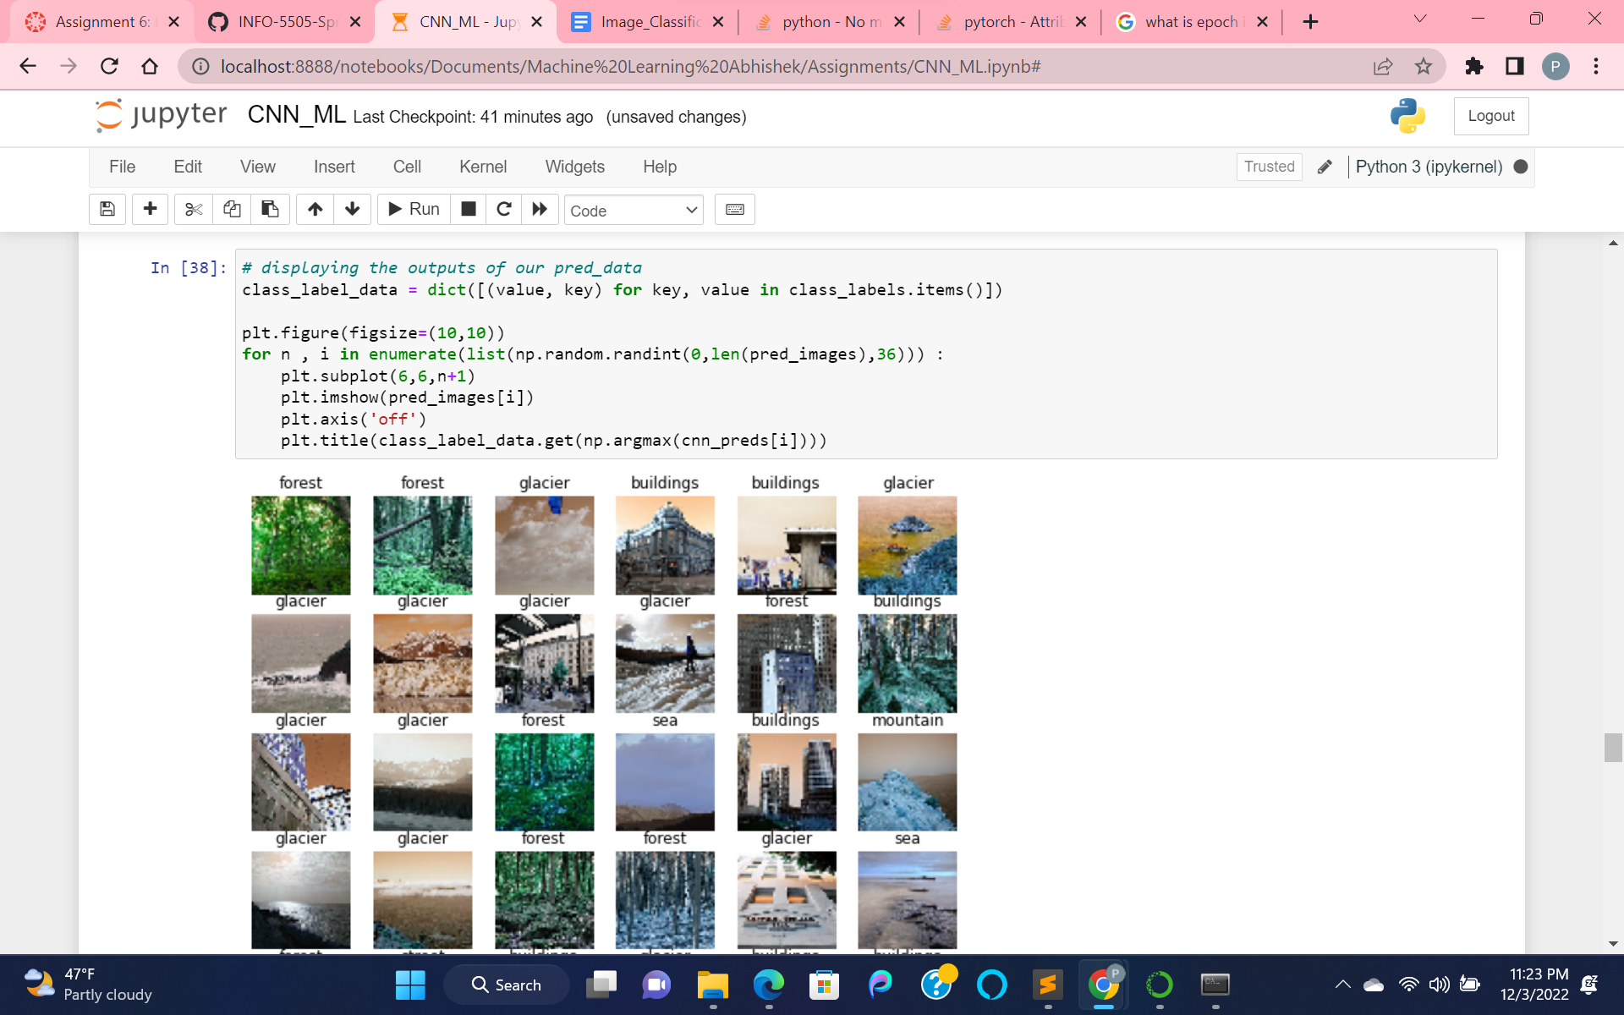

Visualizing all the images or describing them as their particular allocated labels.

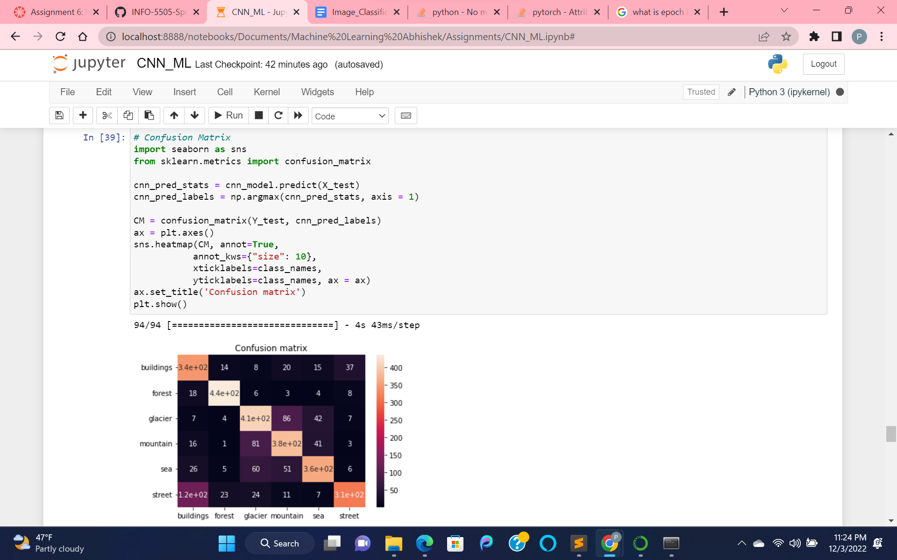

Processed the confusion matrix and visualized it.

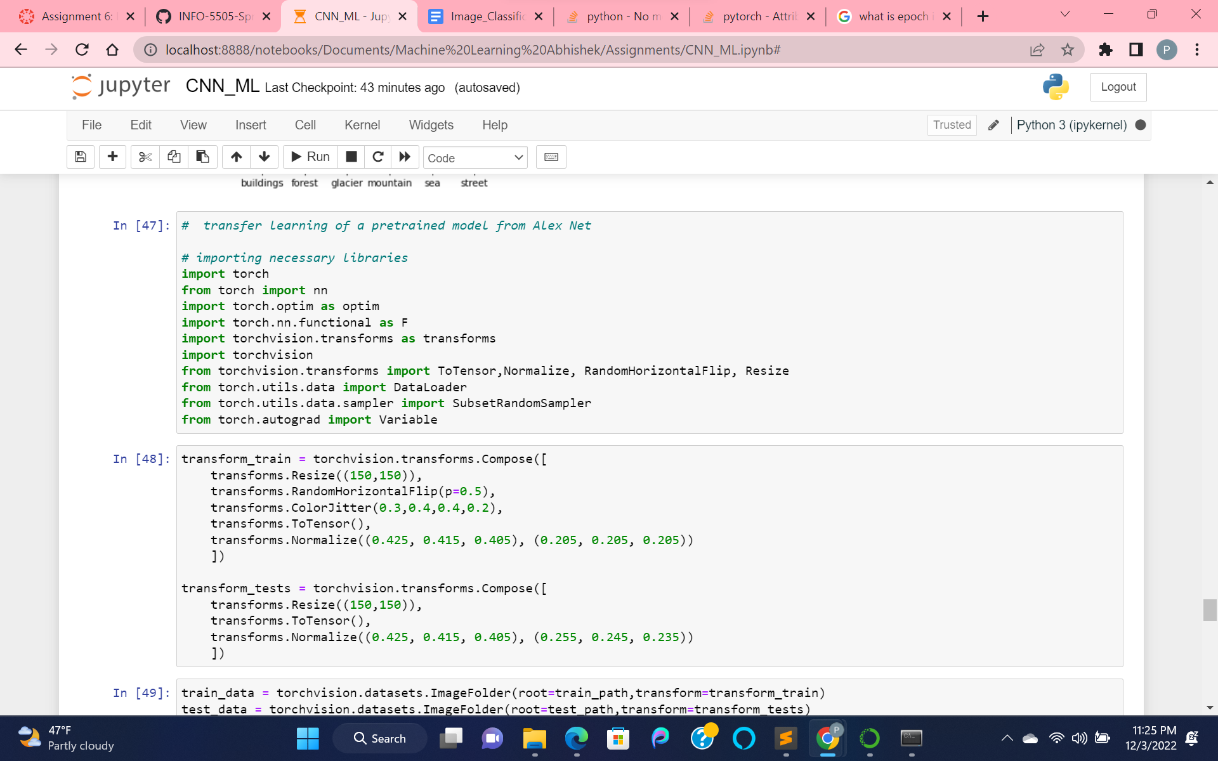

Transferring the learning of a pre-trained model from AlexNet.

Then , imported the necessary libraries and loaded the train, test dataset using torchvision.

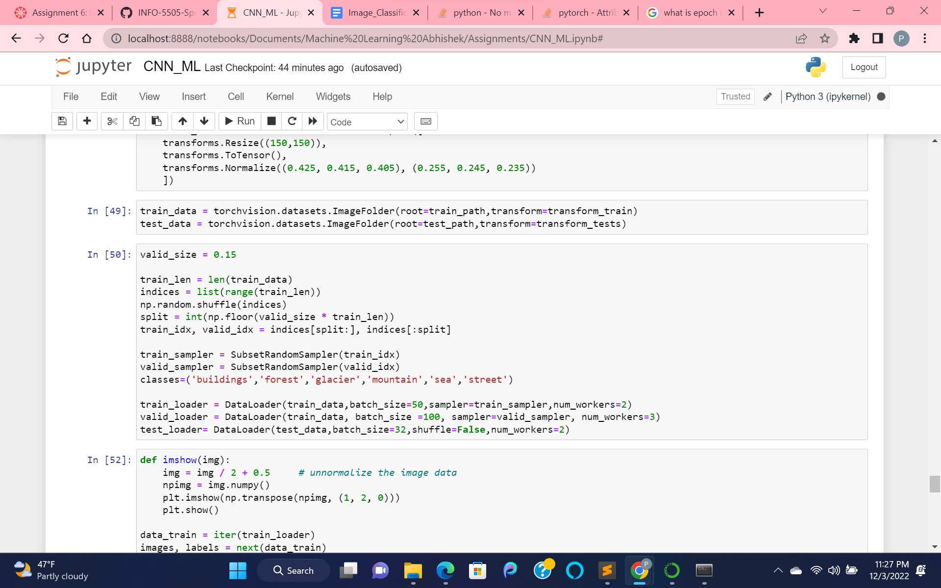

Loaded the samples of train, test data by using train and test sampler with help of num_workers =2.

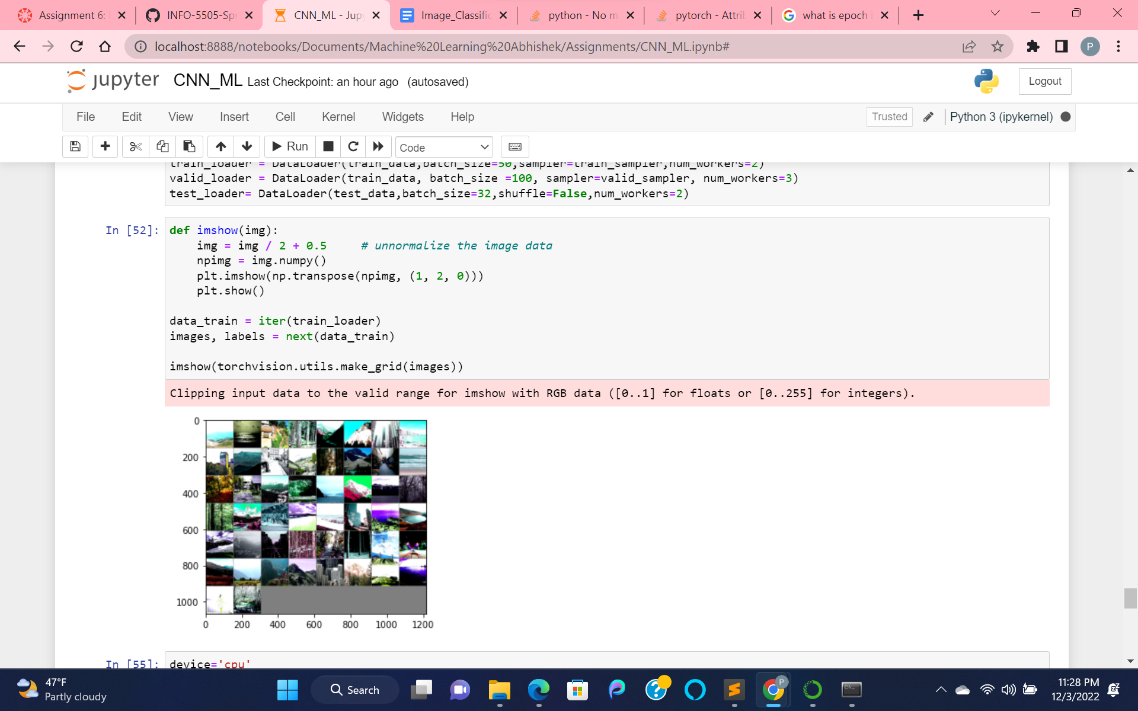

Visualizing all the loaded train_samples of data.

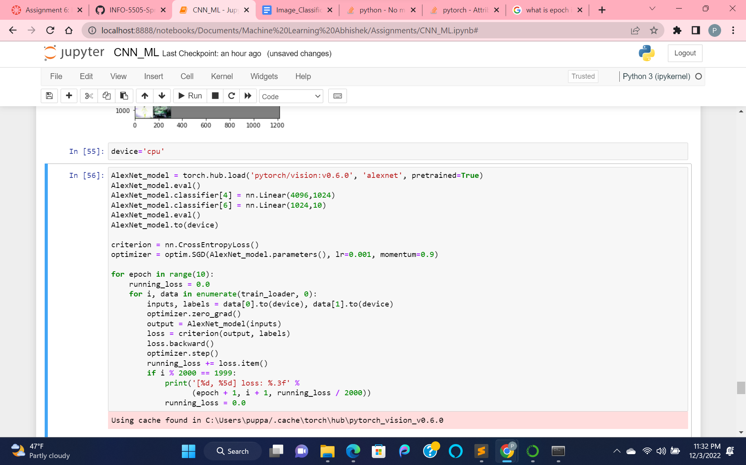

Training the AlexNet model using SGD(stochastic gradient descent) as optimizer by iterating over loaded train_samples.

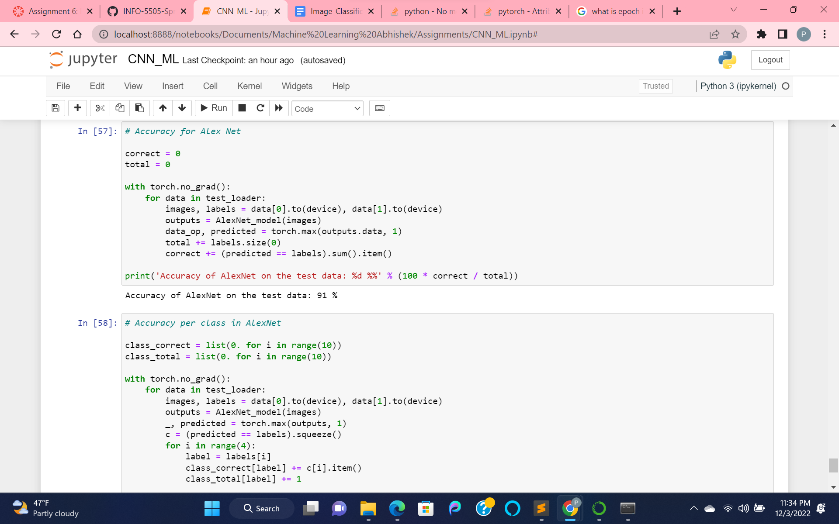

Calculating the accuracy over the AlexNet model, hence we got 91 %.

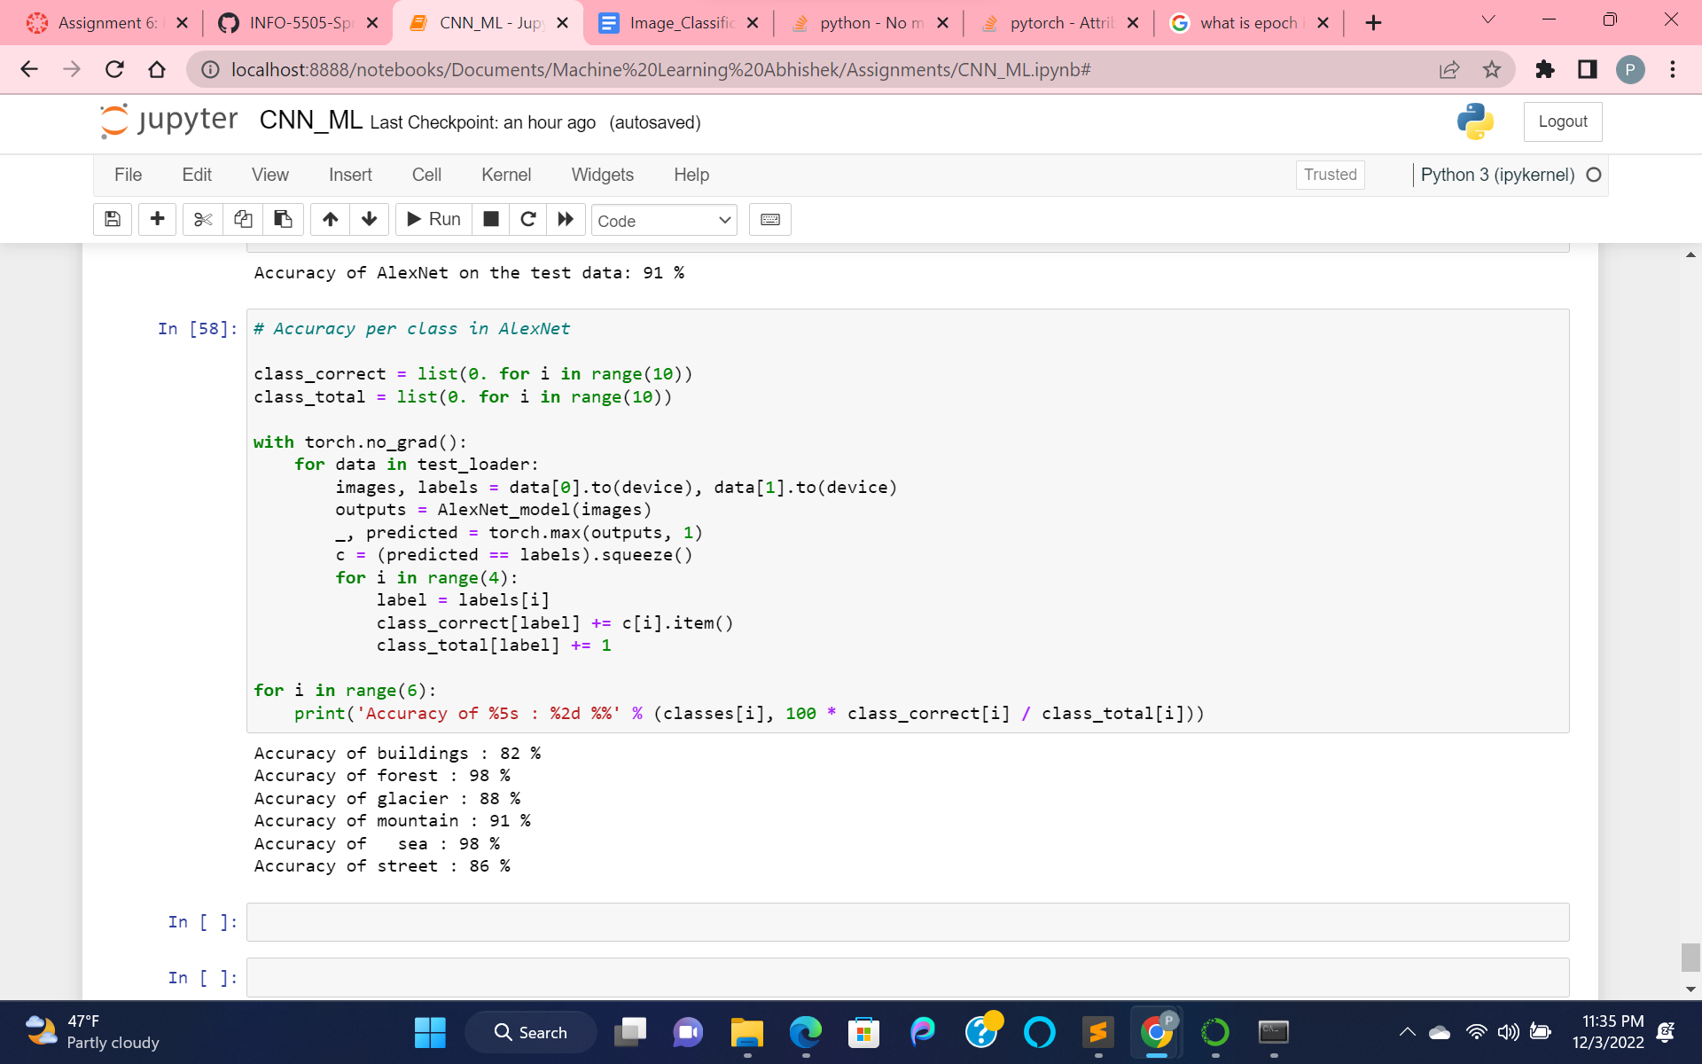

Predicting the accuracy for each class label for our data images.

Building: 82%, Forest: 98%, Glacier: 88%, Mountain: 91%, Sea: 98%, Street: 86%.